English Business Studies Marketing & Advertising

Engleza pentru afaceri- Marketing & Publicitate

CUPRINS

- UNIT 9 PRODUCTS AND BRANDS
- UNIT 10 MARKETING
- UNIT 11 ADVERTISING
- UNIT 21 BUSINESS ETHICS

Unit I

PRODUCTS

- Product policy

1a. Discussion

People and places can also be marketed as products.

Give three examples of brands to which you are loyal to (i.e. which you buy without giving it a moment’s thought). Why are you loyal to them?

Are there any products for which you have no brand preference or loyalty but are what marketers call a ‘brand-switcher’?

Can you think of any products for which the name of the brand is totally unimportant, so that you do not even notice it? (There may be some in your bag or briefcase.)

Give an example of a product line (a group of related products made by the same company). Think of clothes, cosmetics, food, and so on.

1b. Reading

Read the following text, and write a brief heading for each paragraph.

PRODUCTS AND BRANDS

1……………………………………………………………………………………………

Marketing theorists tend to give the word product a very broad meaning, using it to refer to anything capable of satisfying a need or want. Thus services, activities, people (politicians, athletes, film stars); places (holiday resorts), organizations (hospitals, colleges, political parties), and ideas, as well as physical objects offered for sale by retailers, can be considered as products. Physical products can usually be augmented by benefits such as customer advice, delivery, credit facilities, a warranty or guarantee, maintenance, after-sales service, and so on.

2……………………………………………………………………………………………..

Some manufacturers use their name (the ‘family name’) for all their products, e.g. Philips, Colgate, Yamaha. Others including Unilever and Procter & gamble, market various products under individual brand names, with the result that many customers are unfamiliar with the name of the manufacturing company. The major producers of soap powders, for example, are famous for their multi-brand strategy which allows them to compete in various market segments, ant to fill shelf space in shops, thereby leaving less room for competitors. It also gives them a greater chance of getting some of the custom of brand-switchers.
3……………………………………………………………………………………………..

Most manufacturers produce a large amount of products, often divided into product lines. Most product lines consist of several products, often distinguished by brand names, e.g. a range of soap powders, or of toothpastes. Several different items (different sizes or models) may share the same brand name. together, a company’s items, brand and products constitute its product mix. Since different products are always at different stages of their life cycles, with growing, stable or declining sales and profitability, and because markets, opportunities and resources are in constant evolution, companies are always looking to the future, and re/evaluating their product mix.

4……………………………………………………………………………………………..

Companies whose objectives include high market share growth generally have long product lines, i.e. a large number of items. Companies whose objective is high profitability will have shorter lines, including only profitable items. Yet most product lines have a tendency to lengthen over time, as companies produce variations on existing items, or add additional items to cover further market segments. Additions to product lines can be the result of either line-stretching or line- filling. Line-stretching means lengthening a product line by moving either up-market or down-market, i.e. making items of higher or lower quality. This can be carried out in order to reach new customers, to enter growing or more profitable market segments, to react to competitors’ initiatives, and so on. Yet such moves may cause image problems: moving to the lower end of a market dilutes a company’s image for quality, while a company at the bottom of a range may not convince dealers and customers that it can produce quality products for the high end. Line-filling-adding further items in that part of a product range which a line already covers-might be done in order to compete in competitors’ niches, or simply to utilize excess production capacity.

1c. Comprehension

1 Why to the big soap powder producers have a multi-brand strategy?
2 Why do companies’ product mixes regularly change?
3 What factors influence the length of companies’ product lines?
4 What are the potential dangers of line-stretching?
5 Why might companies undertake line-filling?

1d Vocabulary

Find the word or expressions in the text which mean the following.

1 the possibility of paying for a product over an extended period
2 a promise by a manufacturer or seller to repair or replace defective goods during a certain period of time
3 a surface in a store on which goods are displayed
4 consumers who buy various competing products rather than being loyal to a particular brand
5 the standard pattern of sales of a product over the period that it is marketed
6 the extent to which an activity provides financial gain
7 possibilities of filling unsatisfied needs in sectors in which the company can produce goods or services effectively
8 the sales of a company expressed as a percentage of total sales in a given market
9 the set of beliefs that the public at large holds of an organization
10 a small, specialized, but profitable segment of a market

- Developing a new product

You will hear Jogishwar Singh, a director of the Swiss holding company Tégé, talking about the forthcoming launch of ‘Fresc Fries’, a fast-food product that will be sold in vending machines.

2a Discussion

Do you ever use vending machines? If so, what for, why and when/

What are the potential advantages and disadvantages of this form of distribution, for both the seller and the customer?

2b Listening
Listen to the interview. Which of the alternative answers is correct?

1 Fresh Fries machines will be installed
A in cafés and restaurants and other public places.
B in all kinds of places where people come to eat.
C in places where there are lots of people.

2 Fresh Fries are made from

A dried potatoes and water
B fresh potatoes and oil
C powdered potatoes and various secret ingredients.

3 The vending machine will be followed by a smaller machine

A for home and commercial use
B for people to use at home
C for smaller restaurants.

4 The machine has been through a series of prototypes because

A the inventor came up with further inventions
B the inventor made design improvements
C other people gave the inventor new ideas.

5 Inventors usually do not know enough about

A industrial engineering
B raising finance
C the economics and realities of industrial reason the product will succeed all over the world is

6 Jogishwar Singh thinks the most important reason the product will succeed all over the world is
A its speed in delivering the fries
B the fact that the fries will always have exactly the same quality
C the quality of the fries and especially their crispness.

2c Vocabulary

Look at the following words and expressions, and then listen to the interview again, and write down the words and expressions used in the interview that mean nearly the same.

1 a serving of food designed for one person
2 an alternative British word for what Americans call French fries
3 eye-catching, noticeable
4 from which water has been removed
5 the components of which a food product is made
6 a small booth used for selling newspapers, cigarettes, ice cream, and so on
7 the owners of a company
8 a large amount of money
9 uniformity, regularity, sameness (of a product sold worldwide)
10 a symbol or design or the particular form of lettering of a trade mark

2d Discussion

Where would you be likely to use such a machine?
What do you think are Tégés a chances of successfully launching this product in your country?
And in 180 countries?

2e Preparing a report

Imagine that an international vending machine operator is hoping to increase its activities in your country, and has hired you to report on the existing market and to suggest new products that could be distributed via vending machines.

First you have to prepare a report outlining:

- Which products are currently sold it vending machines in your country
- Where such machines are usually situated
- What kind of customers generally use them
- In what circumstances

Then you have to suggest further products that could perhaps be distributed in this way.
Prepare your report with two colleagues.

2f Discussion: M-commerce

One problem with vending machines is the use of money : customers may not have the right change; thieves may try to break into machines; coins might change, requiring machines to be adapted (e.g. the introduction of the euro), etc.

One solution to this is to pay using a mobile phone.

At the time of writing, most people only use mobile phones for calls and text messages. Very few people are used to the idea of buying things with their mobile phones, but this is a field that is developing rapidly. Vending machines are being adapted so that people can buy snacks and drinks by entering a number of their phone, with the price added to their telephone bill.

Mobile phones linked to the internet also allow customers to receive instant information. Can you think of any other goods or services that could be delivered and paid for using machines and mobile phones? Here are some examples from Finland (the country with the highest per capita use of mobile phones) from the year 2000.

- Paying for bus tickets, and finding out when the next buss is due, which can be useful in winter when the temperature is minus 20 degrees
- Getting information about what’s on at your local cinema and paying for the tickets
- A car-wash machine that you operate by dialing a phone number rather than going into a garage to pay

UNIT II

MARKETING

1 Defining marketing

1a Definition

Here is definition of marketing. Complete it by inserting the following verbs in the gaps:

Design develop identify modify persuade-influence

Marketers have to (1)………………………or anticipate a consumer need; (2)………………………a product or service that meets that need better than any competing products or services; (3)………………………………target customers to try the product or service; and, in the long term, (4)……………………………..it to satisfy changes in consumer needs or market conditions. Marketers can (5)…………………………particular features, attractive packaging, and effective advertising, that will (6)…………………………………….consumers’ wants. Marketing thus begins long before the product or service is put on the market; it combines market research, new product development, distribution, advertising, promotion, product improvement, and so on.

Here is a second definition of marketing (as opposed to selling):
(Peter Drucker: Management: Tasks, Responsabilities, Practices)
There will always, one can assume, be a need for some selling. But the aim of marketing is to make selling superfluous. The aim of marketing is to know and understand the customer so well that the product or service fits him and sells itself. Ideally, marketing should result in a customer who is ready to buy.

What do you think of this definition? Can selling really become superfluous, even if the customer is ready to buy? Or is there one important aspect of business that this definition overlooks?

Can you think of any examples of products for which marketers anticipated a consumer need (i.e. products you had never imagined needing before they where developed)?
e.g. A special plastic mat for the bottom of the bath tub in order to prevent slipping or any other kinds of accidents.

1b Vocabulary

Match up the words or expressions on the left with the definition on the right, then make sentences of your own for each of these phrases.

1 distribution channel A all the companies or individuals involved in moving a particular goof or service from the producer to the consumer
2 to launch a product B an idea for a new product, which is tested with target consumers before the actual product is developed
3 market opportunities C attributes or characteristics of a product: quality, price, reliability, etc.
4 market research D dividing a market into distinct groups of buyers who have different requirements or buying habits
5 market segmentation E places where goods are sold to the public - shops, stores, kiosks, market stalls, etc.
6 packaging F possibilities of filling unsatisfied needs in sectors in which a company can profitably produce goods or services
7 points of sale G someone who contacts existing and potential customers, and tries to persuade them to buy goods or services
8 product concept H collecting analyzing and reporting data relevant to a specific marketing situation (such as a proposed new product)
9 product features I to introduce a new product onto the market
10 sales representative J wrappers and containers in which products are sold.

1 | 2 | 3 | 4 | 5 | 6 | 7 | 8 | 9 | 10
a | i | f | h | d | j | e | b | c | g

1c Reading

Look quickly through the following text and decide which paragraphs are about these subjects:
……………-company-to-company marketing
……………-identifying market opportunities
……………-the marketing mix
……………-the selling and marketing concepts
……………-the importance of market research

THE CENTRALITY OF MARKETING

1 Most management and marketing writers now distinguish between selling and marketing. The ‘selling concept’ assumes that resisting consumers have to be persuaded by vigorous hard-selling techniques to buy non-essential goods or services. Products are sold rather than bought. The ‘marketing concept’, on the contrary, assumes that the producer’s task is to find wants and fill them. In other words, you don’t sell what you make, you make what will be bought. As well as satisfying existing needs, marketers can also anticipate and create new ones. The markets for the Walkman, video recorders, videogame consoles, CD players, personal computers, the internet, mobile phones, mountain bikes, snowboards, and genetic engineering, to choose some recent examples, were largely created rather than identified.
2 Marketers are consequently always looking for market opportunities-profitable possibilities of filling unsatisfied needs or creating new ones in areas in which the company is likely to enjoy a differential advantage, due to its distinctive competencies (the things it does particularly well). Market opportunities are generally isolated by market segmentation. Once a target has been identified, a company has to decide what foods or service to offer. This means that much of the work of marketing has been done before the final product or service comes into existence. It also means that the marketing concept has to be understood throughout the company, e.g. in the production department of a manufacturing company as much as in the marketing department itself. The company must also take account of the existence of competitors, who always have to be identified, monitored and defeated in the search for loyal customers.
3 Rather than risk launching a product or service solely on the basis of intuition or guesswork, most companies undertake market research (GB) or marketing research (US). They collect and analyse information about the size of a potential market, about consumers’ reactions to particular product or service feature, and so on. Sales representatives, who also talk to customers, are another important source of information.
4 once the basic offer, e.g. a product concept, has been established, the company has to think about the marketing mix, i.e. all the various elements of a marketing programme, their integration, and the amount of effort that a company can expend on them in order to influence the target market. The best-known classification of these elements is the ‘Four Ps’: product, place, promotion and price. Aspects to considere in marketing products include quality, features (standard and optional), style, brand name, size, packaging, services and guarantee. Place in a marketing mix includes such factors as distribution channels, locations of points of sale, transport, inventory size, etc. Promotion groups together advertising, publicity, sales promotion, and personal selling, while price includes the basic list price, discounts, the length of the payment period, possible credit terms, and so on. It is the job of a product manager or a brand manager to look for ways to increase sales by changing the marketing mix.
5 It must be remembered that quite apart from consumer markets (in which people buy products for direct consumption) there exists an enormous producer or industrial or business market, consisting of all the individuals and organizations that acquire goods and services that are used in the production of other goods, or in the supply of services to others. Few consumers realize that the producer market is actually larger than the consumer market, since it contains all the raw materials, manufactured parts and components that go into consumer goods, plus capital equipment such as buildings and machine, supplies such as energy and pens and paper, and services ranging from cleaning to management consulting, all of which have to be marketed. There is consequently more industrial than consumer marketing, even trough ordinary consumers are seldom exposed to it.
1d Comprehension

Which of the following three paragraphs most accurately summarizes the text in 1c, and why?

First summary:

Marketing means that you don’t have to worry about selling your product, because you know it satisfies a need. Companies have to identify market opportunities by market segmentation: doing market research, finding a target market, and producing the right product. Once a product concept has been established, marketers regularly have to change the marketing mix-the product’s features, its distribution, the way it is promoted, and its price-in order to increase sales. Industrial goods-components and equipment for producers of other goods-have to be marketed as well as consumer goods.

Second summary:

The marketing concept has now completely replaced the old-fashioned selling concept. Companies have to identify and satisfy the needs of particular market segments. A product’s features are often changed, as are its price, the places in which it is sold, and the way in which it is promoted. More important then the marketing of consumer goods is the marketing of industrial or producer goods.

Third summary:

The marketing concept is that a company’s choice of what goods and services to offer should be based on the goal of satisfying consumers’ needs. Many companies limit themselves to attempting to satisfy the needs of particular market segments. Their choice of action is often the result of market research. A product’s features, the methods of distributing and promoting it, and its price, can all be changed during the course of its life, if necessary quite apart from the marketing of consumer products, with which everybody is familiar, there is a great deal of marketing of industrial goods.

1e Comprehension

Look at the following diagrams from Marketing Management by Philip Kotler.

According to the text in 1c, which of these diagrams best illustrates a company that has adopted the marketing concept?
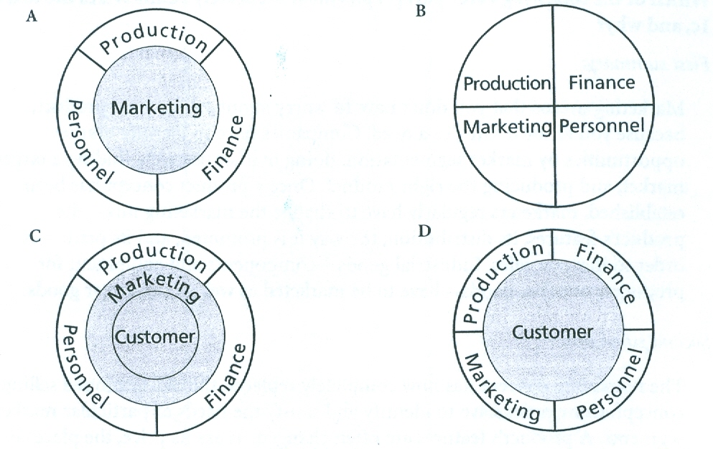

2 The importance of market research

2a Marks & Spencer Store
- History
- Policy
- Christmas policy
- Consistency/ the feeling of being at home regardless of the store venue
- The staff’ wellbeing more important than the customers’ satisfaction

2b Case Study: Market research

Suppose that you were part of the marketing team responsible for the following product concepts:

1 A new line of swimwear, to be sold by a chain of department stores
2 Fresh Fries
3 A new range of expensive hi-fi equipment
4 A new English Dictionary for foreign learners

What market research would you do before developing the products? What specific information would you need? Where could you get it?

In each case, which of the following sources of information do you think would be the most useful, and why?

- Focus group interviews, in which several members of the target market are invited (and paid a small fee) to meet and discuss the product concept
- Internal research: analysis data already available in the company’s accounts and sales departments, which keep records of sales, orders, inventory size, and so on
- Printed sources of secondary data, including business newspapers, magazines and trade journals, competitors annual reports, official government statistics, and reports published by private market research agencies
- Questionnaire research, by telephone, mail, or personal interviewing
- The company’s own sales staff
- Other sources

UNIT III

ADVERTISING

1 Ways of advertising

1a Vocabulary

Identify the different advertising media.
Eight different ways advertising are illustrated (one of them by the indirect means of sports sponsorship). Classify them according to how much you think each of these advertising messages costs, going from the most expensive to the cheapest.

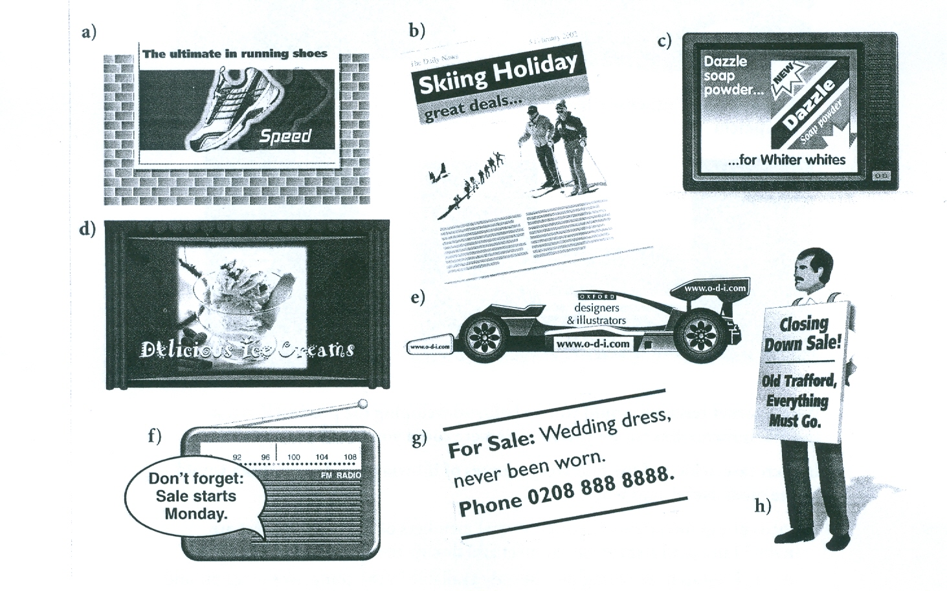

1b Reading

Read the text opposite and answer the following questions.
1 What is the best kind of advertising?
2 Why do most companies use advertising agencies?
3 When a company hires an advertising agency, what are the roles of both parties?
4 What is a media plan?
5 Why does advertising become ineffective after a certain point?

HOW COMPANIES ADVERTISE

Advertising informs consumers about the existence and benefits of products and services, and attempts to persuade them to buy them. The best form of advertising is probably word-of-mouth advertising, which occurs when people tell their friends about the benefits of products or services that they have purchased. Yet virtually no providers of goods or services rely on this alone, but use paid advertising, which is designed to build up their reputation rather than to sell particular products.

Although large companies could easily set up their own advertising departments, write their own advertisements, and buy media space themselves, they tend to use the services of large advertising agencies. These are likely to have more resources, and more knowledge about all aspects of advertising and advertising media than a single company. The most talented advertising people generally prefer to work for agencies rather than individual companies as this gives them the chance to work on a variety of advertising accounts (contracts to advertise products or services). It is also easier for a dissatisfied company to give its account to another agency than it could be to fire its own advertising staff.

The client company generally gives the advertising agency an agreed budget; a statement of the objects of the advertising campaign, known as a brief; and an overall advertising strategy concerning the message to be communicated to the target customers. The agency creates advertisements (the word is often abbreviated to adverts or ads), and develops a media plan specifying which media – newspapers, magazines, radio, television, cinema, posters, mail etc. – will be used and in which proportions. (On television and radio, ads are often known as commercials.) Agencies often produce alternative ads or commercials that are pre-tested in newspapers, television stations, etc. in different parts of a country before a final choice is made prior to a national campaign.

The agency’s media planners have to decide what percentage of the target market they want to reach (how many people will be exposed to the ads) and the number of times they are likely to see them. Advertising people talk about frequency or ‘OTS’ (opportunities to see) and the threshold effect – the point at which advertising becomes effective. The choice of advertising media is generally strongly influenced by the comparative cost of reaching 1.000 members of the target audience, the cost per thousand (often abbreviated to CPM, using the Roman numeral for 1.000). The timing of advertising campaigns depends on factors such as purchasing frequency and buyer turnover (new buyers entering the market).

How much to spend on advertising is always problematic. Some companies use the avoiding advertising wars. Others set their ad budget at a certain percentage of current sales revenue. But both these methods disregard the fact that increased ad spending or counter-cyclical advertising can increase current sales. On the other hand, excessive advertising is counter-productive because after too many exposures people tend to stop noticing ads, or begin to find them irritating. And once the most promising prospective customers have been reached, there are diminishing returns, i.e. an ever-smaller increase in sales in relation to increased advertising spending.

1c Vocabulary

Find the terms in the text which mean the following.

1 free advertising, when satisfied customers recommend products to their friends
2 advertising that mentions a company’s name but not specific products
3 companies that handle advertising for clients
4 a contract with a company to produce its advertising
5 the amount of money a company plans to spend in developing its advertising and buying media time or space
6 the statement of objectives of an advertising campaign that a client works out with an advertising agency
7 the advertising of a particular product or service during a particular period of time
8 a defined set of customers whose needs a company plans to satisfy
9 the people who choose where to advertise, in order to reach the right customers
10 the fact that a certain amount of advertising is necessary to attract a prospective customer’s attention
11 choosing to spend the same amount on advertising as one’s competitors
12 advertising during periods or seasons when sales are normally relatively poor

1d Discussion

Which of the following claims do you agree with?

1 Advertising is essential for business, especially for launching new consumer products.
2 A large reduction of advertising would decrease sales.
3 Advertising often persuades people to buy things they don’t need.
4 Advertising lowers the public’s taste.
5 Advertising raises prices.
6 Advertising does not present a true picture of products.
7 Advertising has a bad influence on children.

In a well known survey, the Harvard Review asked 2.700 senior business managers whether they agreed with these statements. The survey produced some unexpected results. Which of the following percentages do you think go with which of the statements above?

41% 49% 51% 60% 72% 85% 90%

After matching up these figures and statements, look at the true figures on page 177.
After reading the opinions expressed in the Harvard Review survey, do you want to revise the opinions you expressed above?

2 Radio commercials

2a Listening

Listen once to the three radio commercials, which come from music-based radio stations in London.
- What are the products and services being advertised?
Now listen again to each of the commercials in turn, as many times as necessary to answer the questions which follow.

2b Commercial

1 Which three aspects of the service are emphasized?
2 What, according to the ad, will be the effect of the first two of them on the customer?
3 Why do you think these three aspects were chosen, and why does the ad use these particular verbs?
4 What is the short, last sentence of the ad?
5 What else does the ad use apart from words?
2c Commercial 2

1 What is the horror story here, and why?
2 Unusually, the listener is not expected to understand everything that is said in this ad. Why not?
3 The ad mentions home entertainment systems. What other terms does it use instead of the more common stereo, radio, television, and video recorder?
4 Do you find this ad amusing?

2d Commercial 3
1 How does the ad give an Italian ‘flavour’? Can you think of any way in which this could have been done?
2 Which of these three ads do you prefer, and why?

2e Scripting a radio commercial

In small groups, write a script for a 20-second commercial to be played on a popular English-language radio station, advertising either a well-known product exported by your country, or some form of travel to your country. Remember that you have to persuade and inform, and are not supposed to say anything misleading or untruthful-although of course in this case you are free to invent the name of the company, the details of its service, and so on. You may use music and sound effects if you have access to them. If not, merely indicate what you would use in addition to a voice or voices.

UNIT IV

Business ethics

1 The social responsibility of business

1a Discussion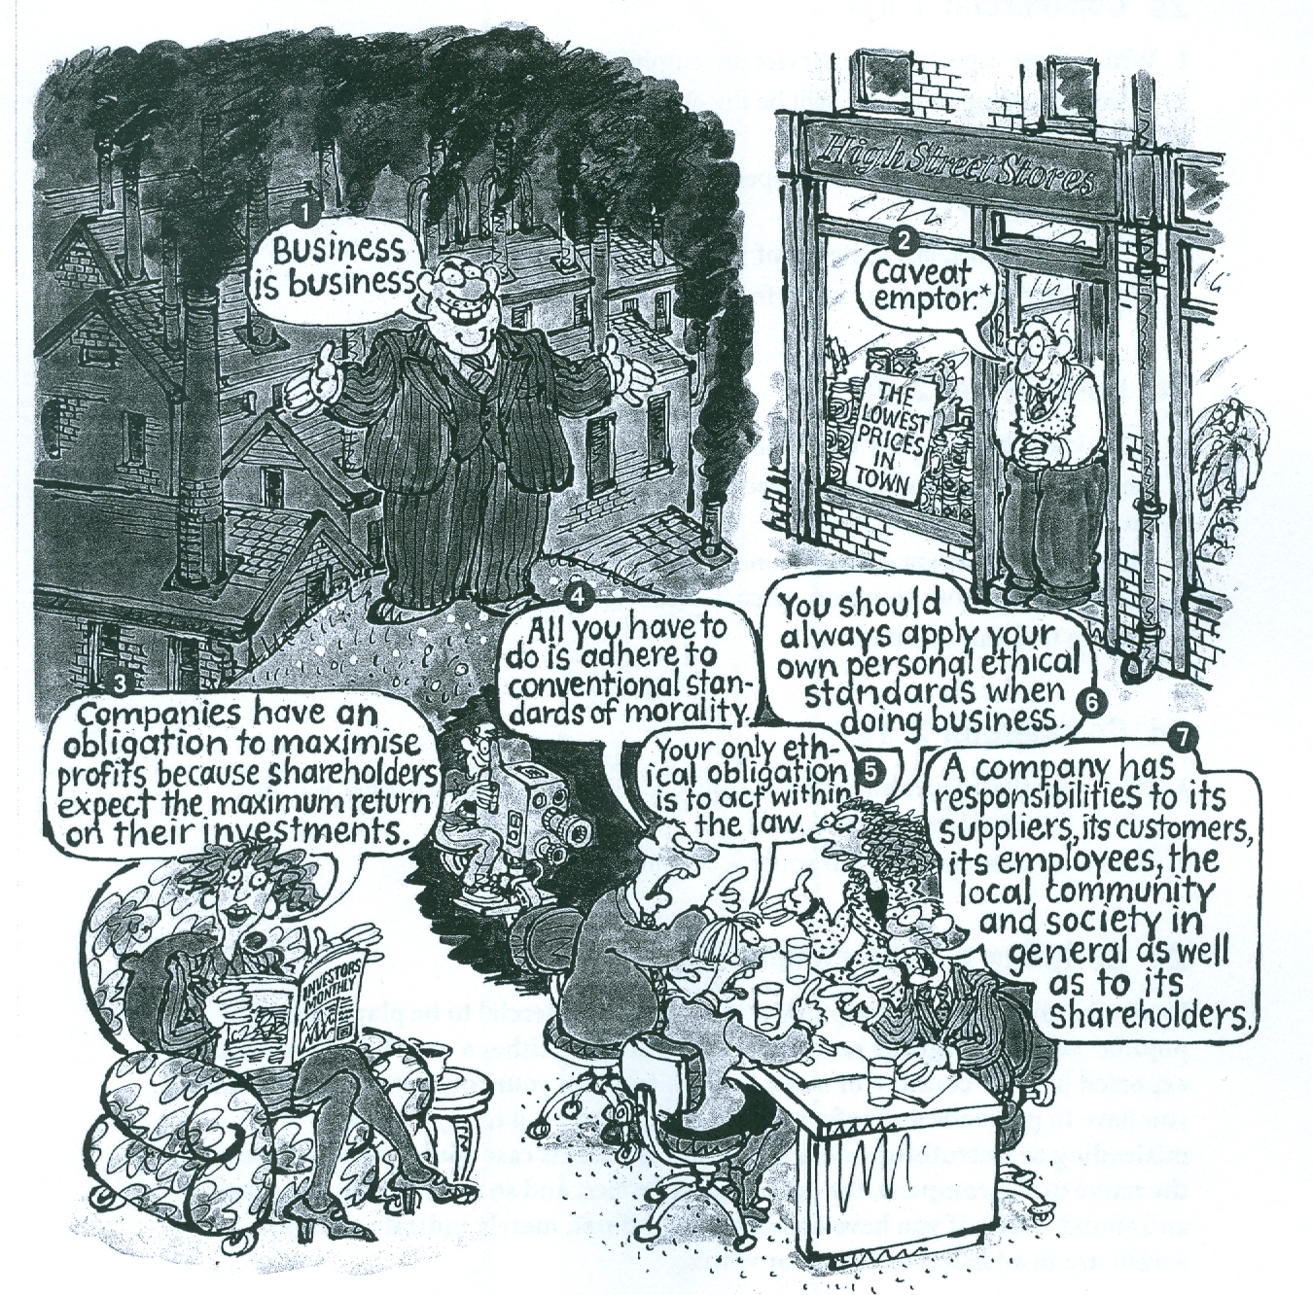

Which of the views expressed in the illustration do you agree with?

1b Reading

Four of the views expressed opposite are referred to in the following text. Which are they?
PROFITS AND SOCIAL RESPONSIBILITY

In the 1920s, many large American corporations began, on a wide scale, to establish pension funds, employee stock ownership, life insurance schemes, unemployment compensation funds, limitations on working hours, and high wages. They built houses, churches, schools and libraries, provided medical and legal services, and gave money to charities. Since this fairly surprising behavior for business corporations, there must be a good explanation.

In The Generous Corporation, Neil J. Mitchell argues that the reason for many of these actions, most of which clearly did not bring immediate cash benefits, was that large corporations had a legitimacy problem. The existence of large corporations showed the classical economic theory of perfect competition to be inadequate. Consequently large corporations introduced ‘welfare capitalism’ as a way of creating favorable public opinion. Rational capitalists, starting with Henry Ford, also realized that a better paid work force would be a more efficient one.

Of course, pure free market theorists disapprove of welfare capitalism, and all actions inspired by ‘social responsibility’ rather than the attempt to maximize profits. Since the benefits of such initiatives are not confined to those who bear the costs, Milton Friedman has criticized them for being unbusinesslike, and for threatening the survival not only of individual corporations but also the general vitality of capitalism. In a newspaper article titled ‘The social responsibility of business is to increase its profits’, he argued that:

In free enterprise, private-property system, a corporate executive is an employee of the owners of the business. He has direct responsibility to his employers. That responsibility is to conduct the business in accordance with their desires, which generally will be to make as much money as possible, while of course conforming to the basic rules of the society, both those embodied in law and those embodied in ethical custom.

Thus executive should not make expenditures on reducing pollution beyond the amount that is required by law or that is in the best interest of the firm. Nor should they deliberately hire less-qualified, long-term unemployed workers, or workers from ethnic minorities suffering from discrimination. To do so is to be guilty of spending the stockholders’ (or the customers’ or the employees’) money. Friedman does not consider the possibility that stockholders might prefer to receive lower dividend but live in a society with less pollution or less unemployment and fewer social problems.

An alternative view to the stockholder model exemplified by Friedman’s article is the stakeholder model outlined, for example, in John Kenneth Galbraiths book, The new Industrial State. According to this approach, business managers have responsibilities to all the groups of people with a stake in or an interest in or a claim on the firm. These will include suppliers, customers, employees, and the local community, as well as the stockholders. A form which is managed for the benefit of all its stakeholders, will not, for example, pollute the area around its factories, or close down a factory employing several hundred people in a small town with no other significant employers, and relocate production elsewhere in order to make small financial savings. Proponents of the stakeholder approach suggest that suppliers, customers, employees, and members of the local community should be strongly represented on a company’s board of directors.

1c Comprehension

Write questions, relating to the text, which these could be the answers.

1 According to Mitchell, in order to generate favourable public opinion.
2 So that the workers will probably be more loyal to the company, and will have more money to spend on products made by the firm and others.
3 Because he believes such behavior to be unbusinesslike, and therefore dangerous for the company, and for capitalism in general.
4 According to Friedman, generally to receive as big a dividend as possible.
5 According to Friedman, only the country’s laws and ethical customs.
6 Less pollution, or lower unemployment, for example.
7 Anyone who has a claim on or an interest in a firm, such as suppliers, customers and employees.
1d Vocabulary

Find words or expressions in the text which mean the following.

1 institutions or organizations that provide help for people in need
2 acceptability, according to law and public opinion
3 the situation when there are a large number of sellers and buyers, freedom to enter and leave markets, a complete flow of information, and so on
4 a condition of general well-being (and government spending designed to achieve this)
5 menacing, endangering
6 liveliness, health, energy, strength
7 an economic system in which anyone can attempt to raise capital, form a business, and offer goods or services
8 complying with or following (rules, etc.)
9 expressed, given a material form
10 supporters, people who argue in favour of something.

2 Ethics and the law

2a Discussion

Milton Friedman, while dismissing the notion of ‘social responsibility’, still argues that a business must conform to the basic rules of society. In your opinion, do the following activities, several of which are not illegal, conform to the basic rules of society, or not?

1 Bribing corrupt foreign officials in order to win foreign orders, on the grounds that where bribery is a way of life, you have no alternative if you want to win a contract.
2 industrial espionage - spying on competitors’ R&D departments with concealed cameras and microphones, bribing their employees, etc. - rather than doing your own expensive research and development.
3 Selling supposedly durable goods with ‘built-in obsolescence’, i.e. which you know will not last more than a few years.
4 Spending money on lobbying, i.e. trying to persuade politicians to pass laws favourable to your particular industry.
5 Telling only half the truth in advertisements, or exaggerating a great deal ,or keeping quiet about the bad aspects of a product.
6 undertaking ‘profit smoothing’ i.e. using all the techniques of ‘creative accounting’ to hide big variations in profit figures from year to year, and threatening to replace the auditors if they object.
7 ‘Whistle blowing’, i.e. revealing confidential information to the police or to a newspaper, e.g. that a company is breaking health and safety regulations and therefore putting people’s lives in danger, or illegally selling arms to foreign dictators.

